**VIETNAM NATIONAL UNIVERSITY**

**INTERNATIONAL SCHOOL**



**FINAL PROJECT REPORT**

***Title: Natural disaster sensor for industry***

|  |  |
| --- | --- |
| **CLASS:** | **INS3108 - INS310801** |
| **LECTURER:** | **TS. Nguyen Thanh Tung** |
| **GROUP:** | **8** |
| **MEMBER:** | **Doan Duy Long – 22070843**  **Ma Thanh Tung – 22070904** |

# 

# TABLE OF CONTENT

TABLE OF CONTENT 1

1.1 Background 2

1.2 Project Overview 2

1.3 Project Objectives 3

1.4 Significance of the System 3

1.5 Scope of the Project 4

CHAPTER 2: HARDWARE 5

2.1 ESP8266 Wi-Fi Module 5

2.2 SW-420 Vibration Sensor 6

2.3 MQ-135 Gas Sensor 6

2.4 DHT-11 Temperature and Humidity Sensor 7

2.5 SIM-800A GSM Module 8

2.6 NeoPixel RGB LEDs 9

2.7 OLED Display 9

2.8 3V Buzzer 10

2.9 Button Component for System Testing 11

CHAPTER 3: PROGRAMMING 12

3.1 Sensor Data Collection and Processing 12

3.2 Data Display 13

3.2.1 Screen display 13

3.2.2 Serial Display 14

3.2.3 Blynk IoT integration 14

3.2 Alert System 15

3.3.1 SMS alert with SIM-800A GSM module 15

3.3.2 Audio and visual alert 16

CHAPTER 4: RESULTS 17

4.1 Sensor Data Accuracy 17

4.2 Alert System Performance 17

4.4 Remote Monitoring via Blynk 18

CHAPTER 5: CONCLUSION 19

5.1 General Assessment 19

5.6 Challenges and Limitations 19

5.2 Scalability for Future Works 20

CHAPTER 1: INTRODUCTION

## 1.1 Background

Natural disasters, such as earthquakes, floods, wildfires, and hurricanes, pose significant risks to human life, infrastructure, and the environment. In industries, these disasters can lead to catastrophic losses, halt operations, and even result in fatalities. The need for timely detection and early warning systems has never been more critical in mitigating the impacts of these events, particularly in industrial settings where operations are sensitive to disruptions.

In recent years, advancements in sensor technologies and the Internet of Things (IoT) have provided opportunities for more effective disaster monitoring systems. By integrating various sensors that can detect changes in environmental conditions or physical disturbances, it is now possible to create systems that continuously monitor for potential disaster scenarios. These systems can alert stakeholders, such as plant managers or safety personnel, in real-time, enabling them to take appropriate actions to minimize harm.

## 1.2 Project Overview

This project presents a Natural Disaster Sensor System designed to monitor environmental and physical conditions that could indicate the onset of a natural disaster. The system combines multiple sensors with a communication platform (via Blynk IoT API) to provide real-time data, display warnings on an OLED display, and send SMS alerts in the event of an emergency.

The core components of the system include:

* SW-420 Vibration Sensor: Detects vibrations indicative of seismic activity (e.g., earthquakes).
* MQ-135 Gas Sensor: Monitors air quality for harmful gases, which can indicate a hazardous environment, such as after an industrial fire or gas leak.
* DHT-11 Sensor: Measures temperature and humidity to provide environmental data, which is essential for monitoring flood conditions or heat waves.
* SIM-800A GSM Module: Used for sending SMS alerts to predefined phone numbers in case of detected anomalies.
* NeoPixel RGB LEDs: Provide visual alerts, changing colors based on the severity of the situation.
* ESP8266 Wi-Fi Module: Connects the system to the internet for remote monitoring via the Blynk platform.

These components are integrated to monitor key disaster indicators and provide both local and remote notifications.

## 1.3 Project Objectives

The main objectives of this project are as follows:

* Develop an integrated disaster detection system that can monitor multiple environmental parameters (such as vibration, gas concentration, temperature, and humidity).
* Enable real-time communication by sending SMS alerts via the SIM-800A GSM module, ensuring that the relevant personnel are notified immediately in case of a disaster.
* Provide a visual indication of disaster status through the NeoPixel RGB LEDs and display critical sensor data on the OLED screen for on-site monitoring.
* Create a cloud-based IoT system using the Blynk platform to enable remote monitoring of the sensor data, allowing for continuous observation from anywhere.

## 1.4 Significance of the System

The integration of sensors with IoT technologies in industrial disaster detection systems has immense potential to save lives, reduce damage to property, and improve the overall safety of industrial operations. By deploying a system capable of detecting and alerting for natural disasters in real-time, industries can:

* Mitigate risks: Detect potential threats such as earthquakes, gas leaks, or temperature fluctuations before they escalate.
* Ensure safety: Provide timely alerts to prevent injury or loss of life.
* Improve emergency response: Enable quick decision-making and more effective evacuations or safety measures through automated alerts.

Furthermore, the ability to send SMS alerts and display real-time data on the Blynk platform ensures that both on-site personnel and remote operators can stay informed and react swiftly to emerging threats.

## 1.5 Scope of the Project

This project is primarily focused on the prototyping and testing of the sensor system with a limited set of natural disaster indicators (earthquakes, gas leaks, and environmental anomalies). While the system is designed for industrial applications, its modularity allows for future expansion to include additional sensors or to adapt to other natural disasters, such as floods, wildfires, or hurricanes.

In this report, we will detail the hardware and software components used in the system, the integration process, testing and calibration procedures, and the results obtained during system operation. The final goal is to demonstrate the potential of the system for early disaster detection and provide recommendations for future improvements.

# CHAPTER 2: HARDWARE

The natural disaster sensor system integrates several hardware components that work together to detect environmental and physical changes indicative of potential natural disasters. These components include sensors for detecting vibrations, gas concentrations, temperature and humidity, as well as modules for communication and visualization. This chapter will describe the individual components and how they are assembled into a functional system.

## 2.1 ESP8266 Wi-Fi Module

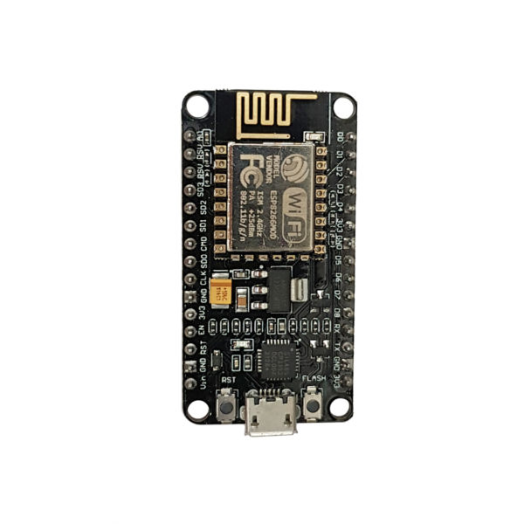

The ESP8266 is a low-cost Wi-Fi module that enables the sensor system to connect to the internet and transmit data to remote servers or monitoring platforms, such as the Blynk IoT API. It allows for the integration of remote monitoring, where users can access sensor data from anywhere. The ESP8266 is responsible for sending real-time data from the sensors to the cloud and receiving any necessary commands for system control.

- Key Features:

* Integrated Wi-Fi support for wireless communication.
* Low power consumption, making it suitable for IoT applications.
* Multiple GPIO (General Purpose Input/Output) pins for interfacing with other sensors and modules.

- Role in the Project: The ESP8266 connects the disaster detection system to the internet, enabling remote monitoring and alerting through the Blynk app and sending SMS alerts via the SIM-800A GSM module.

## 2.2 SW-420 Vibration Sensor

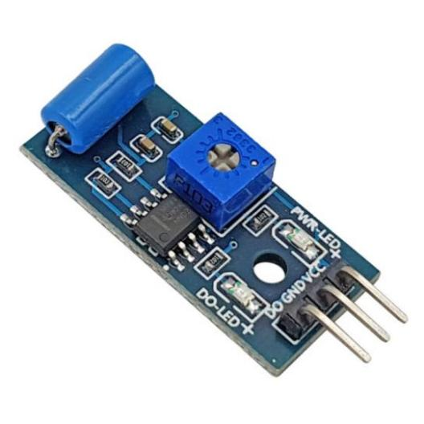

The SW-420 vibration sensor is used to detect vibrations that could indicate seismic activity or physical disturbances caused by events like earthquakes. This sensor is typically used in systems designed to detect tremors or ground shifts, which are vital for early warnings in earthquake-prone regions.

- Key Features:

* Detects vibrations or motion.
* Simple analog output (high or low signal) based on the presence or absence of vibration.
* Low power consumption.

- Role in the Project: The SW-420 sensor is used to monitor for ground vibrations and provide early detection of seismic events. If vibrations above a predefined threshold are detected, the system triggers an alert to notify the user.

## 2.3 MQ-135 Gas Sensor

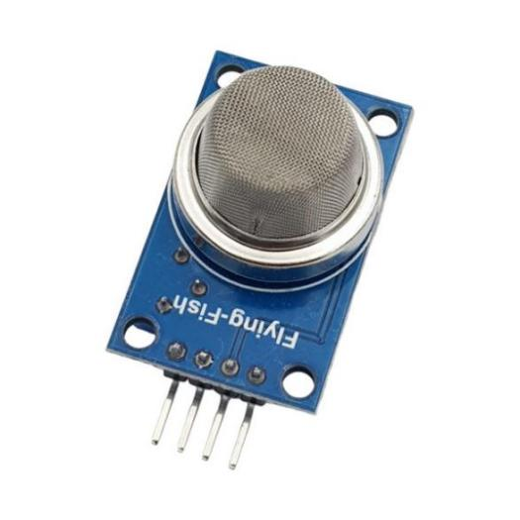

The MQ-135 gas sensor is a versatile sensor used for detecting various gases, including carbon dioxide (CO₂), ammonia (NH₃), benzene (C₆H₆), alcohol (C₂H₅OH), and smoke. In the context of this system, it is used to detect hazardous gases that could result from industrial accidents or natural disasters like wildfires or chemical spills.

- Key Features:

* Detects a range of gases that are hazardous to human health.
* Analog output, which can be calibrated for specific gas concentrations.
* Requires a heating period for proper sensor calibration.

- Role in the Project: This sensor monitors air quality in the environment, providing alerts in case of dangerous gas concentrations, such as those that might result from a fire or industrial leak.

## 2.4 DHT-11 Temperature and Humidity Sensor

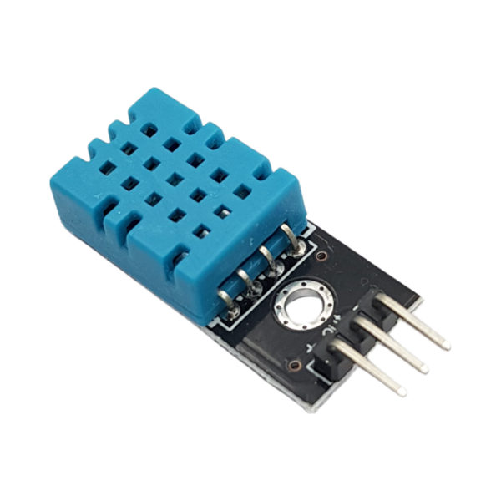

The DHT-11 is a basic digital temperature and humidity sensor that provides reliable data for monitoring environmental conditions. This sensor is critical for tracking changes in temperature and humidity that could indicate the onset of a natural disaster, such as flooding or extreme heat conditions.

- Key Features:

* Measures temperature in the range of 0°C to 50°C with ±2°C accuracy.
* Measures humidity from 20% to 90% with ±5% accuracy.
* Digital output for easy integration with microcontrollers like the ESP8266.

- Role in the Project: The DHT-11 sensor is used to continuously monitor the temperature and humidity levels in the environment. Any sudden or extreme changes can serve as early indicators of certain natural disasters, such as hurricanes or flooding.

## 2.5 SIM-800A GSM Module

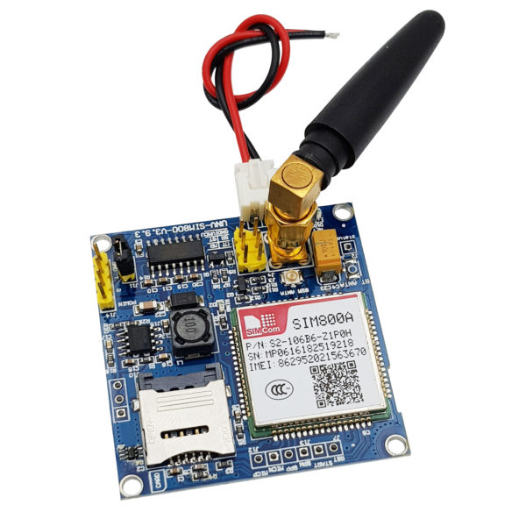

The SIM-800A GSM module is responsible for sending SMS alerts to users when a disaster is detected. This module communicates with the ESP8266 to send notifications to mobile phones, providing immediate warning to personnel on-site or remote operators.

- Key Features:

* Supports SMS, voice, and data communication.
* Can send and receive SMS to alert users of dangerous situations.
* Works with various SIM cards for cellular communication.

- Role in the Project: When the system detects a natural disaster (e.g., high vibration from an earthquake or dangerous gas concentration), the SIM-800A module sends an SMS to predefined numbers, alerting them of the potential threat and triggering necessary actions.

## 2.6 NeoPixel RGB LEDs

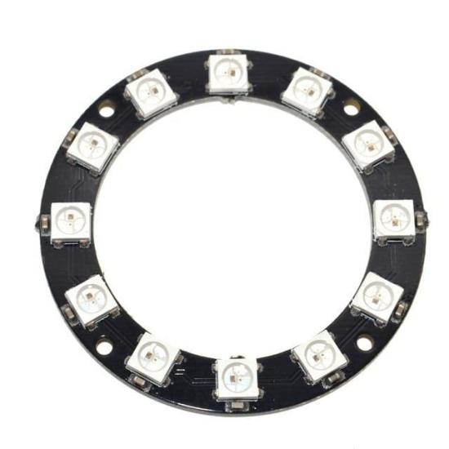

The NeoPixel RGB LEDs provide visual feedback to alert users about the status of the disaster detection system. These LEDs can change colors to signify different levels of threat, such as green for normal conditions, yellow for caution, and red for danger.

- Key Features:

* Simple control via digital pins of the microcontroller.
* Low power consumption.

- Role in the Project: These LEDs are used as a local alert system. The color of the LEDs changes based on the severity of the detected event. For example, green would indicate normal conditions, yellow could indicate a warning level, and red would signal a critical situation requiring immediate attention.

## 2.7 OLED Display

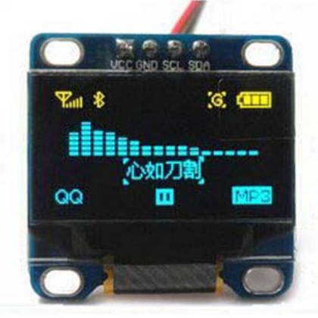

The 0.96 inch Oled screen, I2C interface, 2 colors is used to display real-time data from the sensors, including temperature, humidity, vibration, and gas concentrations. This allows on-site personnel to monitor the conditions of the environment and detect any abnormalities that may require attention.

- Key Features:

* High contrast display that works well in various lighting conditions.
* Can display alphanumeric data and sensor values.
* Low power consumption.

- Role in the Project: The OLED display provides a real-time visual representation of the data collected from the sensors, offering immediate feedback on the environmental conditions being monitored.

## 2.8 3V Buzzer

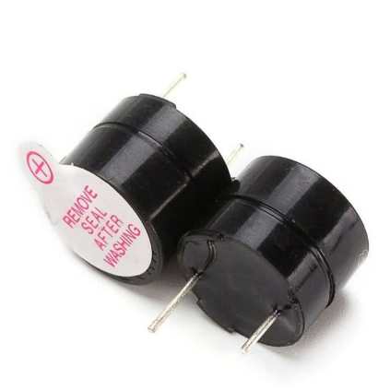

The 3V Buzzer serves as an audible alert mechanism, providing a sound alarm in case of critical disaster conditions. This component ensures that users are immediately aware of the detected disaster or abnormal conditions, even if they are not directly observing the visual indicators or receiving SMS alerts.

- Key Features:

* Operates on a 3V supply.
* Produces a continuous or intermittent tone depending on the disaster's severity.

- Role in the Project: When a disaster is detected—whether it is an earthquake (vibration sensor), dangerous gas levels (MQ-135), or abnormal temperature/humidity levels (DHT-11)—the buzzer activates. The buzzer's sound serves as an immediate, local alarm to alert personnel in the vicinity. The tone can be programmed to change depending on the severity of the situation, providing an audible indication of the system's status.

## 2.9 Button Component for System Testing



The Button Component is used to test the functionality of the entire system, allowing for manual simulation of disaster conditions. This button can be pressed to trigger the alert mechanisms of the system (visual, audible, and SMS) and verify that the sensors, GSM module, LEDs, and buzzer are working correctly.

- Key Features:

* Simple push-button component.
* Can be used for manual triggering of alerts during testing.

- Role in the Project: The button allows the user to test the system without waiting for actual disaster conditions. When pressed, it triggers the same response as if a sensor detected an abnormal situation. This helps verify that the system is functioning properly before deployment and during maintenance.

# **CHAPTER 3: PROGRAMMING**

The software for the natural disaster sensor system integrates the hardware components to achieve the core functionality of disaster detection, alert generation, and remote monitoring. This chapter details the software architecture, which consists of sensor data collection, decision-making, communication through the Blynk IoT platform, SMS notifications, and local alerts through visual (NeoPixel RGB LEDs) and audible (buzzer) feedback.

The software is programmed using the Arduino Integrated Development Environment (IDE), which is compatible with the ESP8266 microcontroller and supports a wide range of IoT sensors and modules. The system operates in real-time, continuously monitoring environmental data, processing it to detect potential disasters, and providing timely alerts both locally (visual and audible) and remotely (SMS and Blynk).

## 3.1 ****Sensor Data Collection and Processing****

The system continuously collects data from various sensors, processes it, and makes decisions based on predefined thresholds. This ensures that the system can detect potential natural disasters, such as earthquakes, gas leaks, or extreme weather conditions.

- Sensor Data Collection:

* SW-420 Vibration Sensor: This sensor detects vibrations and sends a HIGH or LOW signal to the ESP8266, which is read by the analog or digital pins of the microcontroller.
* MQ-135 Gas Sensor: The MQ-135 sensor detects hazardous gases and returns an analog voltage that corresponds to the concentration of gases like CO₂ or ammonia.
* DHT-11 Temperature and Humidity Sensor: The DHT-11 sensor provides digital temperature and humidity data, which is used to monitor environmental changes that could indicate a disaster.

- Data Processing:

The system compares the sensor readings to predefined thresholds to decide when to trigger an alert. For instance, if the vibration exceeds a threshold that signifies an earthquake, or if the gas concentration goes above a safety limit, the system will trigger the alarm.

- Code Example for Sensor Data Collection:

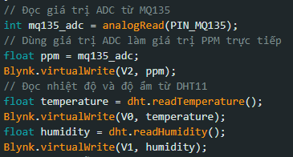

- Role in the Project:

* Continuous monitoring: Keeps track of environmental conditions in real-time.
* Disaster detection: Triggers alerts when any sensor exceeds its predefined threshold.

## 3.2 Data Display

### 3.2.1 Screen display

The system includes a 0.96-inch OLED screen with an I2C interface for visualizing key environmental data.. The screen is communicate with the ESP8266 micro-controller used to present temperature, humidity, and air quality data, along with visual alerts.

- Example Code for OLED Integration:

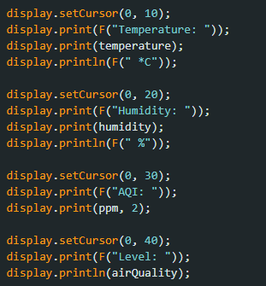







- Role in the Project: Displays real-time environmental data directly on the device.

### 3.2.2 Serial Display

A serial monitor display provides a secondary method for viewing sensor data and alert messages. This is useful for debugging or when the system is connected to a computer via USB.

- Example Code for Serial Display:

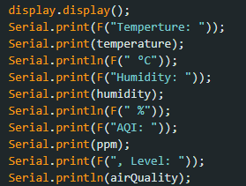

- Role in the Project:

* Alternate Display: Ensures data can still be accessed in the absence of a functional OLED screen.
* Alerts and Debugging: Provides immediate feedback on system alerts and operational status.

### 3.2.3 Blynk IoT integration

Blynk is an IoT platform used to build mobile and web applications to control and monitor hardware remotely. The Blynk API allows the ESP8266 to send data to a Blynk server, where it is displayed in real-time on a mobile or web dashboard. It also allows users to trigger specific actions based on the sensor data or preset conditions.

- Code Example for Blynk Integration:

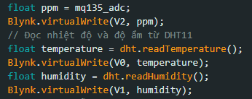

- Role in the Project:

* Real-time monitoring: Visualizes sensor data remotely on the Blynk app.
* Alerting: Displays warning messages based on sensor data (e.g., when gas concentration or vibration levels exceed a certain threshold).
* Allows the user to manually take actions, such as alerts other people.

## 3.2 Alert System

### 3.3.1 SMS alert with SIM-800A GSM module

The SIM-800A GSM module is responsible for sending SMS alerts to emergency contacts when a disaster is detected. This system ensures that even if the user is not actively monitoring the Blynk app, immediate SMS alerts are sent when critical conditions are detected by the sensors.

- SMS Alert Workflow:

* Triggering Condition: The system continuously monitors sensor data. If any sensor's reading exceeds a predefined threshold (e.g., high vibration, high gas concentration, or extreme temperature), it triggers the SMS alert.
* Sending SMS: The ESP8266 sends AT commands to the SIM-800A GSM module to send an SMS containing the alert information.
* Message Content: The message includes the disaster type (e.g., earthquake detected) and instructions for action (e.g., evacuate immediately).

Code Example for Sending SMS:

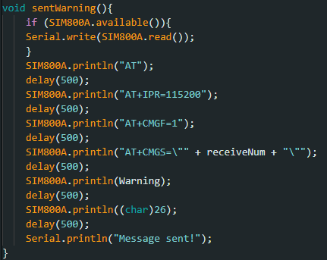

- Role in the Project:

* Emergency alerts: Ensures that users are immediately notified via SMS when a disaster is detected, even without internet access.
* Safety communication: Sends critical information such as the type of disaster and instructions to take action.

### 3.3.2 Audio and visual alert

The audio and visual alert system is a crucial component of the natural disaster sensor system. It provides immediate feedback when a disaster or hazardous condition is detected. This system utilizes a 3V buzzer for audible alerts and NeoPixel RGB LEDs for visual indications.The 3V buzzer produces loud beeps to grab attention during emergencies, NeoPixel RGB LEDs provide dynamic visual feedback based on the detected condition.

- Code Example:

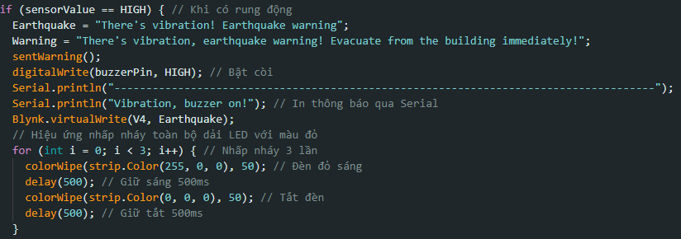

- Role in the Project

* Immediate Feedback: Alerts users in real time about potential hazards, ensuring prompt action.
* Accessibility: Combines audio and visual signals to cater to different user preferences and needs.
* Energy Efficiency: Uses minimal power by operating only during alert conditions.

# CHAPTER 4: RESULTS

The chapter presents the outcomes of the testing and implementation of the natural disaster sensor system. This includes the functionality and performance of hardware components, software integration, and the system's ability to detect disaster conditions and send timely alerts. The system's reliability, accuracy, and effectiveness in real-world scenarios are discussed.

## 4.1 Sensor Data Accuracy

The system's sensors DHT-11, MQ-135, and SW-420 were tested for accuracy under various conditions to simulate real-world disasters.

- DHT-11 Temperature and Humidity Sensor:

* Temperature readings were consistent within ±2°C of reference measurements.
* Humidity readings were within ±5% of actual conditions.
* Overall, the sensor reliably tracked environmental changes relevant to disaster scenarios, such as extreme temperature increases.

- MQ-135 Gas Sensor:

* Detected significant increases in gas concentration when exposed to controlled levels of smoke and CO₂.
* Calibrated for sensitivity to ensure early warning of hazardous gas presence.
* Effectively differentiated between normal and critical gas levels.

- SW-420 Vibration Sensor:

* Responded to vibrations above the threshold level, successfully simulating earthquake conditions.
* Provided consistent and timely signals to the microcontroller for processing.

## 4.2 Alert System Performance

The performance of the alert system, including SMS notifications, visual alerts, and audible signals, was evaluated under simulated disaster conditions.

- SMS Notifications:

* The SIM-800A GSM module sent alerts within 5-10 seconds of a disaster detection event.
* Messages accurately conveyed the type of detected disaster (e.g., gas leak, earthquake).
* Alerts were successfully received on multiple devices, ensuring reliable communication.

- Visual and Audible Alerts:

* NeoPixel RGB LEDs changed colors appropriately based on the severity of detected conditions.
* The 3V buzzer provided a loud and clear alarm, ensuring immediate local awareness.
* The system allowed for manual testing of alerts via the button, confirming functionality.

## 4.4 Remote Monitoring via Blynk

* The integration of the Blynk IoT platform enabled real-time remote monitoring of environmental data.
* The app displayed live sensor readings, including vibration levels, gas concentrations, and temperature/humidity data.
* Data synchronization between the ESP8266 and Blynk servers occurred without noticeable delays.

# **CHAPTER 5: CONCLUSION**

## 5.1 General Assessment

The Natural Disaster Sensor System developed in this project offers a comprehensive and cost-effective solution for detecting and responding to earthquakes and post-event gas leaks in industrial environments. By integrating low cost sensors like the SW-420 for vibration detection, MQ-135 for gas monitoring, and DHT-11 for environmental conditions, the system ensures accurate and reliable monitoring of critical hazards.

The use of ESP8266 as the central micro-controller, along with communication modules such as SIM-800A, enables real-time alerts and remote monitoring via IoT and GSM technologies. The inclusion of OLED displays, 7-segment indicators, and NeoPixel RGB LEDs enhances user interaction and ensures immediate understanding of system status and alerts. The system demonstrated:

* High accuracy in detecting vibrations, gas concentrations, and temperature/humidity changes.
* Effective communication of alerts through SMS, local alarms, and the Blynk IoT platform.
* The system maintained consistent performance during prolonged testing sessions, successfully detecting simulated disasters and responding appropriately.

Overall, the project achieved its goal of creating a reliable, efficient, and scalable system to enhance safety in industrial environments. This system is not only effective in reducing risks associated with natural disasters but also scalable and adaptable for broader applications in industrial safety. By automating critical hazard detection and integrating robust communication features, the project demonstrates significant potential for real-world deployment, enhancing both safety and operational resilience.

## 5.6 Challenges and Limitations

While the system for natural disaster detection and alerting is innovative and effective, it is not without challenges and limitations. Understanding these helps identify areas for improvement and prepare for potential issues in real-world deployments.

* Sensor Accuracy and Calibration: Sensors like the MQ-135 and DHT-11 have inherent inaccuracies and may require periodic recalibration to maintain reliability. Inaccurate data could lead to false positives or missed alerts, reducing trust in the system.
* Power Supply and Management: Continuous operation of sensors, displays, and communication modules demands efficient power management, especially in remote locations with limited access to electricity. Battery drain or power outages could render the system non-functional during critical times.
* Environmental Interference: High levels of environmental noise occasionally affected the accuracy of the vibration sensor.
* Network Dependency: The reliance on Wi-Fi for remote monitoring means that system performance may be impacted in areas with weak or no internet connectivity.

## 5.2 Scalability for Future Works

The modular design allows for the addition of more sensors or components (e.g., flame sensors) to expand its capabilities for other types of disasters, improving safeties of the work environment

* Integration of Additional Sensors: Add flame sensors, wind speed sensors,… to monitor a broader range of disasters. Implement GPS for precise location tracking in case of disaster alerts.
* Improved Network Resilience: Incorporate LoRa or other long-range communication protocols to address Wi-Fi dependency. Add redundancy in GSM communication to ensure message delivery in weak network conditions.
* Enhanced User Interface: Develop a dedicated web dashboard for more detailed monitoring and control. Improve the Blynk app integration to include advanced analytics and historical data visualization.
* Energy Efficiency: Optimize power consumption by using low-power sensors and enabling deep sleep mode for the ESP8266 during idle periods. Explore the use of solar panels for powering the system in remote or off-grid areas.
* AI and Machine Learning: Implement AI algorithms to predict potential disasters based on historical data and trends. Use machine learning for anomaly detection to improve accuracy and reduce false alarms.
* Industrial Adaptability: Customize the system for specific industrial requirements, such as monitoring for chemical leaks in factories or structural health in buildings.